Contents

1 🔧What’s New 2

2 🚀 Fixed Defects 2

3 🚀 Fixed Issues 2

4 Accessibility fixes 3

5 🚀 Deployments 4

5.1 Infrastructure 4

5.1.1 File Updates 4

5.1.2 Deployments 4

5.2 Web Apps 5

**5.3** Mobile 5

5.3.1 Deployment guidance 5

6 💻 Reviewers 6

7 Appendix 7

7.1 Post Deployment Verification 7

7.2 Running Pipeline from Tags 7

Release Notes

# 🔧What’s New

New user stories delivered: **None**

# 🚀 Fixed Defects

The following bugs reported in SIT are addressed in the current interim build –

| **ID** | **Title** | **Severity** | **Priority** |
| --- | --- | --- | --- |
| [36463](https://dev.azure.com/TASMUCP/TASMU%20MSI/_workitems/edit/36463) | Marketplace, About TASMU Page Our Vision has duplicate Title | 3 - Medium | 2 |
| [36468](https://dev.azure.com/TASMUCP/TASMU%20MSI/_workitems/edit/36468) | NF- B2B - 'Related portals' on Marketplace portal to be changed to 'Related Portals' | 4 - Low | 2 |

# 🚀 Fixed Issues

The following issues reported are addressed in the current build –

| **ID** | **Work Item Type** | **Title** | **Priority** | **Assigned To** |
| --- | --- | --- | --- | --- |
| [36126](https://dev.azure.com/TASMUCP/TASMU%20MSI/_workitems/edit/36126) | Issue | NF-Security-iOS-A local adversary can hijack authenticated sessions due to a high session-inactivity period | 3 | Chirag Bakliwal |
| [36128](https://dev.azure.com/TASMUCP/TASMU%20MSI/_workitems/edit/36128) | Issue | NF-Security-iOS-SSL certificate pinning is not enforced | 3 | Chirag Bakliwal |
| [36470](https://dev.azure.com/TASMUCP/TASMU%20MSI/_workitems/edit/36470) | Issue | Carousel images have black bar underneath in iPad | 2 | Chirag Bakliwal |

# Accessibility fixes

The following issues related to accessibility have been addressed in this build –

| **ID** | **Work Item Type** | **Title** | **Assigned To** | **State** | **Tags** |
| --- | --- | --- | --- | --- | --- |
| [35007](https://dev.azure.com/TASMUCP/TASMU%20MSI/_workitems/edit/35007) | Issue | NF-Accessibility-IOS iPhone Application-Home Screen-Form: Complaint / Feedback | v-sengala | Resolved | Accessibility; Citizen Mobile Apps’; Mobile; Report 6; validated in test |
| [36109](https://dev.azure.com/TASMUCP/TASMU%20MSI/_workitems/edit/36109) | Issue | NF-Accessibility-IOS iPhone Application-“Smart Buildings” | v-sengala | Resolved | Accessibility; Citizen Mobile Apps’; Mobile; Report 8; validated in test |
| [36110](https://dev.azure.com/TASMUCP/TASMU%20MSI/_workitems/edit/36110) | Issue | NF-Accessibility-IOS iPhone Application- Profile Forms, use of Language | v-sengala | Resolved | Accessibility; As designed; Citizen Mobile Apps’; Mobile; Report 8 |
| [36111](https://dev.azure.com/TASMUCP/TASMU%20MSI/_workitems/edit/36111) | Issue | NF-Accessibility-IOS iPhone Application- Profile Forms, Salutation Combo Box | v-sengala | Resolved | Accessibility; Citizen Mobile Apps’; Mobile; Report 8; validated in test |
| [36112](https://dev.azure.com/TASMUCP/TASMU%20MSI/_workitems/edit/36112) | Issue | NF-Accessibility-IOS iPhone Application- Profile Forms, Date of Birth and Passport Country | v-sengala | Resolved | Accessibility; Citizen Mobile Apps’; Mobile; Report 8; validated in test |
| [36113](https://dev.azure.com/TASMUCP/TASMU%20MSI/_workitems/edit/36113) | Issue | NF-Accessibility-IOS iPhone Application- Profile Forms, Profile Forms, Address | v-sengala | Resolved | Accessibility; Citizen Mobile Apps’; Mobile; Report 8 |
| [36114](https://dev.azure.com/TASMUCP/TASMU%20MSI/_workitems/edit/36114) | Issue | NF-Accessibility-IOS iPhone Application- Accounts | v-sengala | Resolved | Accessibility; Citizen Mobile Apps’; Mobile; Report 8; validated in test |

# 🚀 Deployments

## Infrastructure

Pull Request – [Pull request 7208: Merge TASMU CP into TASMU MSI - 01 June 2021 - Repos (azure.com)](https://dev.azure.com/TASMUCP/TASMU%20MSI/_git/infra/pullrequest/7208)

### File Updates

1. Add/Update following parameter files -

|  |  |  |  |
| --- | --- | --- | --- |
| **Module** | **Parameter Files** | **Action** | **Properties** |
| StorageAccount | st<sub>appsdiag<env>we-01 | Update | Refer PRs: [7195](https://dev.azure.com/TASMUCP/TASMU%20Central%20Platform/_git/infra/pullrequest/7195) for the changes required to be incorporated. |
| StorageAccount | st<sub>shrddiag<env>we-01 | Update | Refer PRs: [7195](https://dev.azure.com/TASMUCP/TASMU%20Central%20Platform/_git/infra/pullrequest/7195) for the changes required to be incorporated. |

### Deployments

1. Run the following pipelines –
   1. CD-rg-<sub>-**apps-mon**-<env>-we-01-Master-Release
   2. CD-rg-<sub>-**shrd-mon**-<env>-we-01-Master-Release
   3. CD-rg-<sub>-apps-**int**-<env>-we-01-Master-Release

## Web Apps

|  |  |
| --- | --- |
| **Tag** | **Pipeline Name** |
| SIT_Web_01Jun2021 | [CD-WebApps-Prd-Release](https://dev.azure.com/TASMUCP/TASMU%20Central%20Platform/_build?definitionId=1020) |

## Mobile

### Deployment guidance

* 1. Add the PRE/PROD certificate used for TASMU backend services into ADO library as secure files (certificate). This should be avail in AKV and used for SQCP APIs.
  2. A new variable named ‘**Mobile-CertName’** added for higher environments’ variable group in ADO. Update its value with the cert name you just uploaded.
  3. Update the CI/CD as the following:
     1. Add ‘DownloadSecureFile’ task before build tasks – see TST definitions as reference. Note that you need to provide certificate name accordingly – It will be different than used for non-prod environment.
     2. Add CopyFiles task – see TST definitions as reference.
     3. 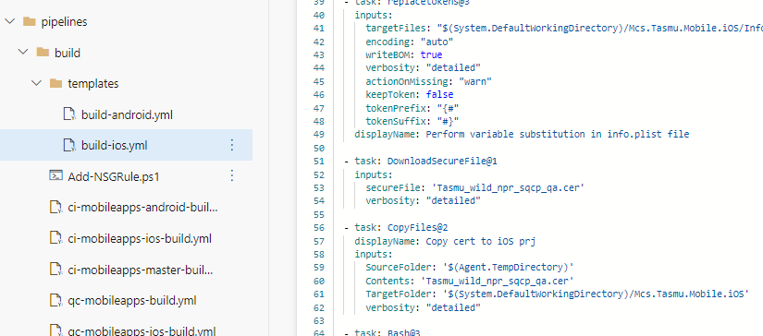
     4. If more clarity is required, reach out Microsoft Mobile Team

|  |  |  |
| --- | --- | --- |
| **Platform** | **Build Id** | **Pipeline Link** |
| Android | 44653 | <https://dev.azure.com/TASMUCP/TASMU%20Central%20Platform/_build/results?buildId=44653&view=results> |
| iOS | 44654 | <https://dev.azure.com/TASMUCP/TASMU%20Central%20Platform/_build/results?buildId=44654&view=results> |

# 💻 Reviewers

|  |  |
| --- | --- |
| Prepared By | Manvir Kaur, Sumit Gupta, Mecit Atmaca |
| Company name | Microsoft |
| Reviewed by | Ravi Sankar Pillutla, Anil Erkek, Subhajit Chatterjee |
| Approved by | Ashwani Sharma |

# Appendix

## Post Deployment Verification

1. Function Apps Running
2. <https://func-cpp-apps-ckan-pre-we-01.azurewebsites.net/>
3. <https://func-cpp-apps-qnasync-pre-we-01.azurewebsites.net/>
4. <https://func-cpp-apps-luistra-pre-we-01.azurewebsites.net/>
5. <https://func-cpp-apps-intbpa-pre-we-01.azurewebsites.net/>
6. <https://func-cpp-apps-intntf-pre-we-01.azurewebsites.net/>
7. <https://func-cpp-apps-pt-pre-we-01.azurewebsites.net/>
8. Marketplace Portal - <https://marketplace.pre.sqcp.qa/en/>
9. Bot – Chat with bot on marketplace
10. My Tasmu Portal - <https://mytasmu.pre.sqcp.qa/en/>
11. Account Portal - <https://account.pre.sqcp.qa/en/>
12. Admin Portal Portal - [https://cpadmin.pre.sqcp.qa](https://cpadmin.pre.sqcp.qa/)  (Login screen should come)
13. API Config access - <https://api.pre.sqcp.qa/config/api/feature>
14. Open Data Portal - <https://opendata.pre.sqcp.qa/>

## Running Pipeline from Tags

